Final Report: Implementation

# **Card 1:**

A user should be able to register for an account on Shoe++

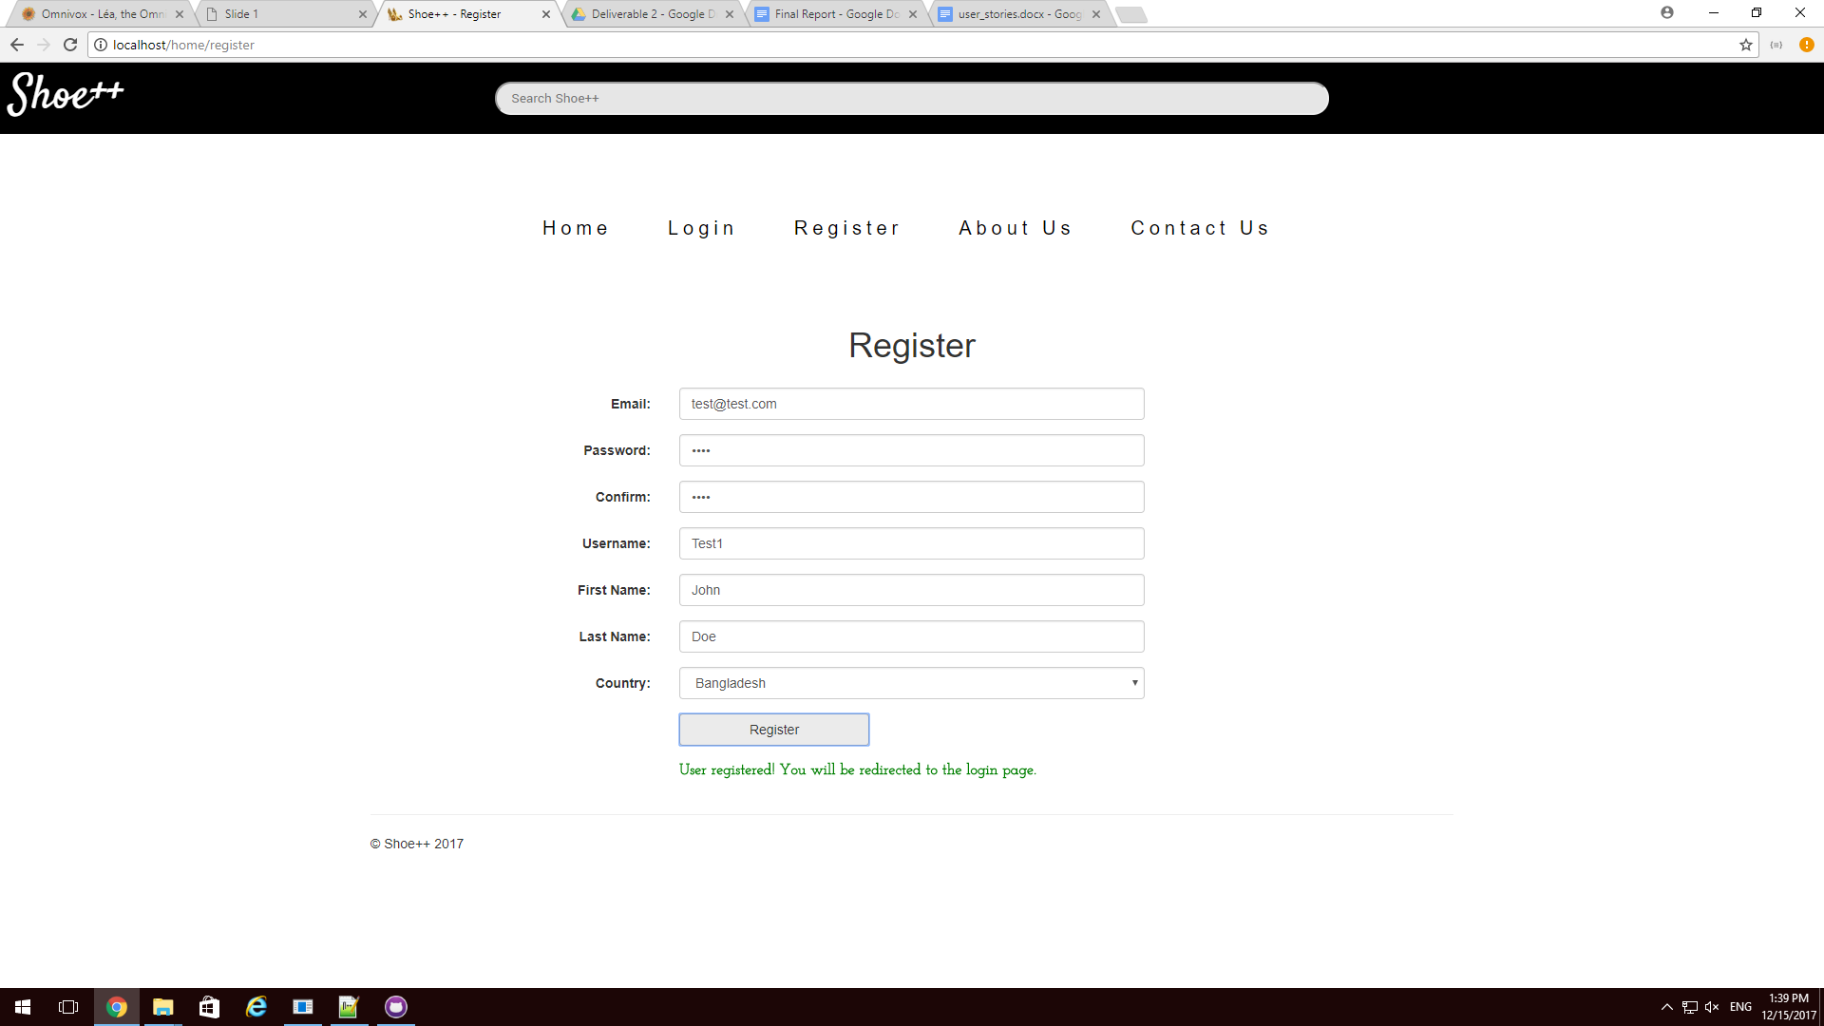

A demonstration of the registration form. Once the user has clicked the “Register” button and the system detects that all inputs are valid, the message “User registered! You will be redirected in the login page”

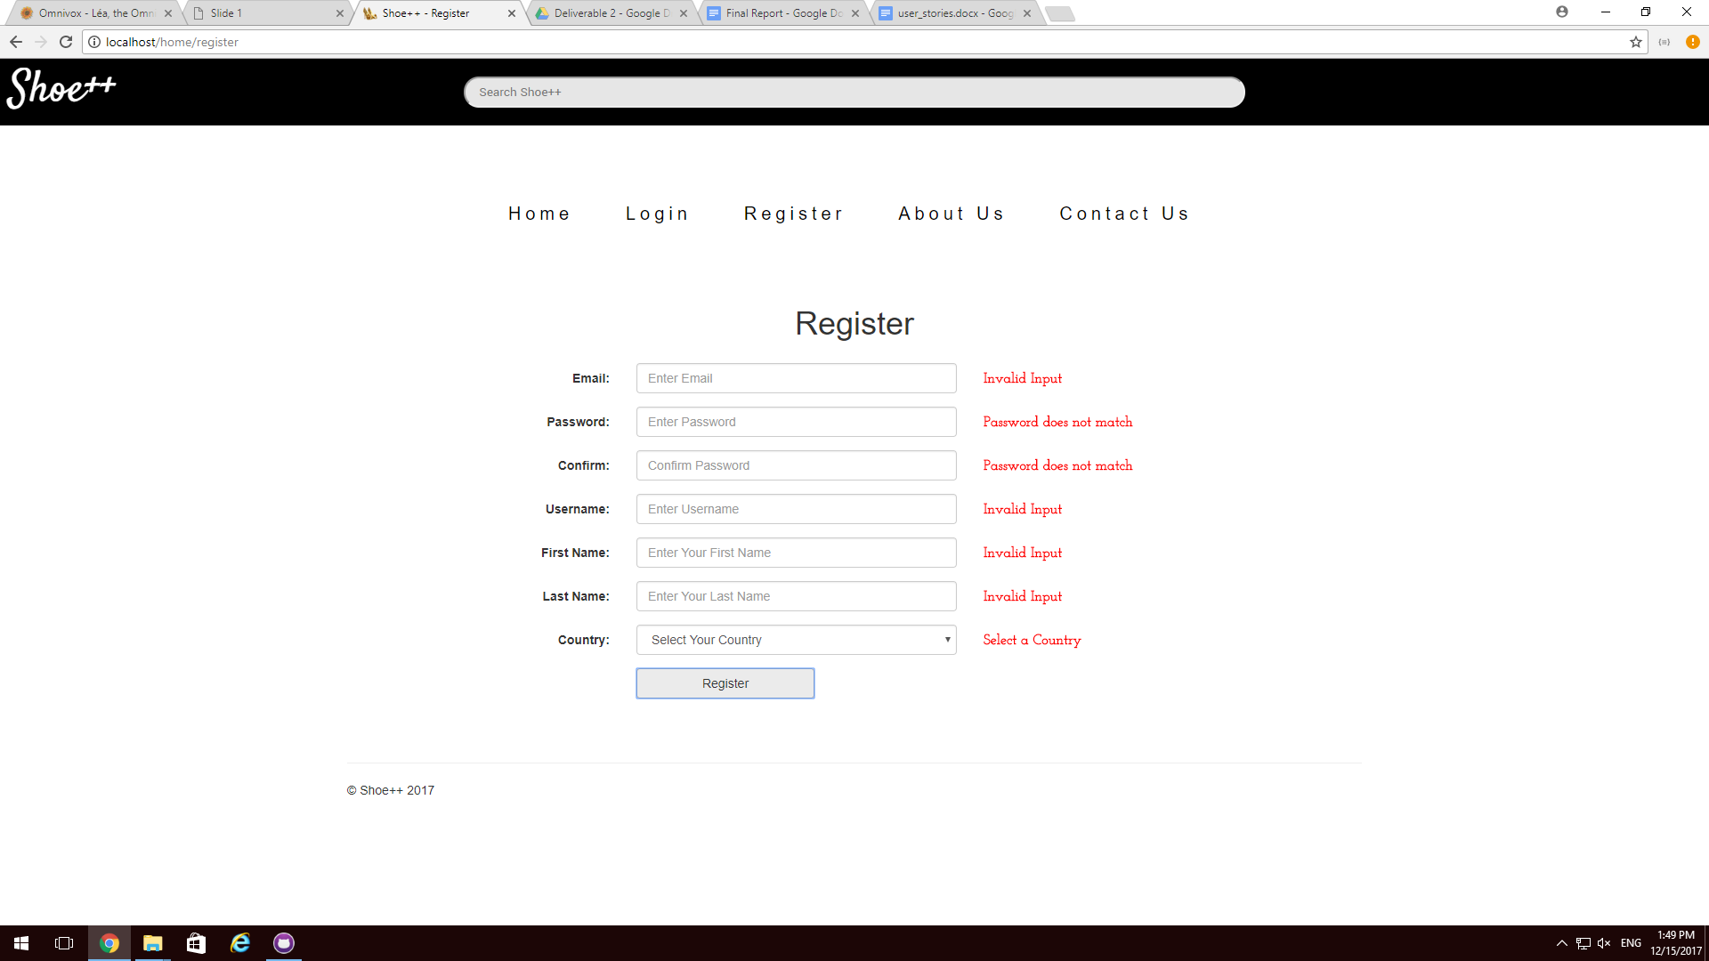

A failed registration attempt. When the user clicks the register button and the system detects invalid input, a message in red is shown next to each incorrect field.

# 

# 

# **Card 2:**

A user can login to his / her account on Shoe++

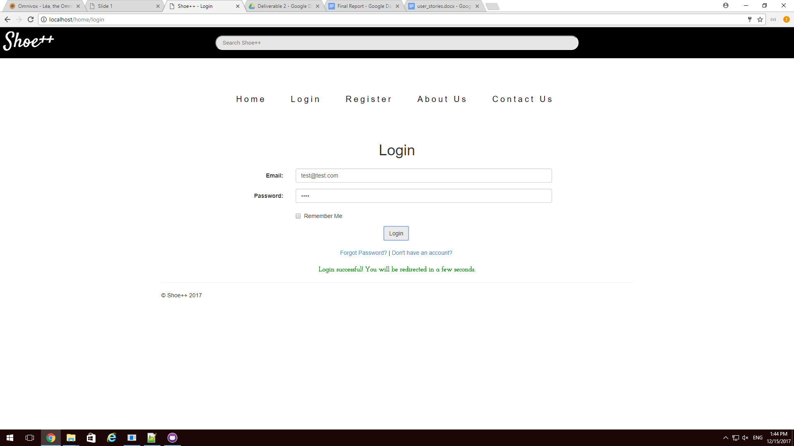

The login form. Once the user has logged in with valid credentials, the text “Login successful! You will be redirected in a few seconds” shows up.

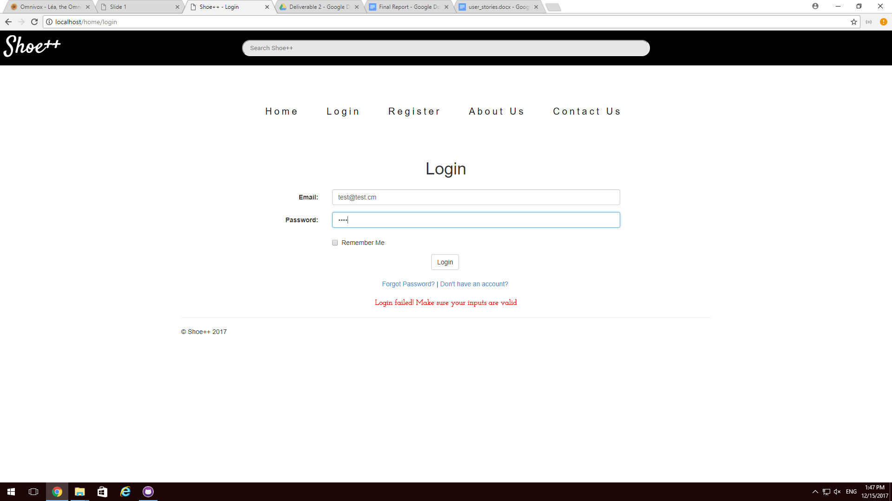

A failed login attempt. If the user credentials are invalid, the text “Login failed! Make sure your inputs are valid” is shown.

# 

# 

# **Card 3:**

A user can logout of his / her account on Shoe++

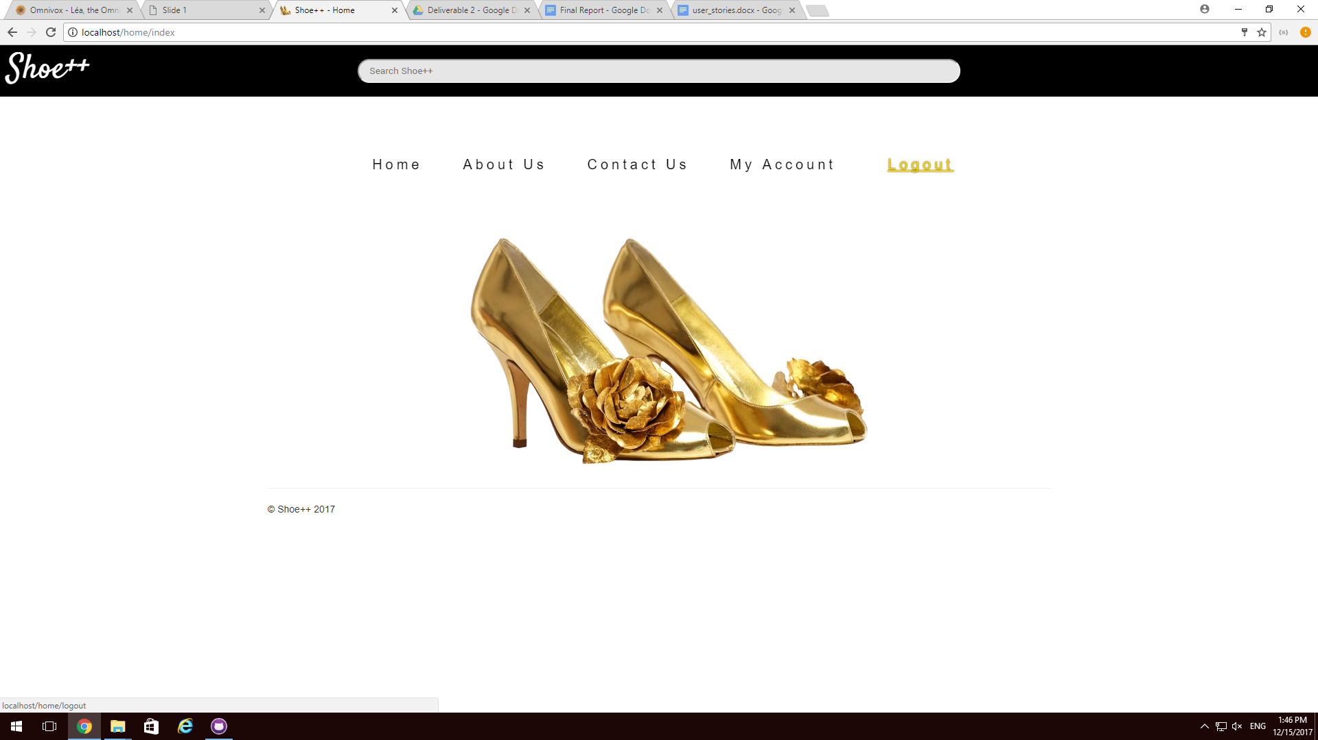

On the navigation bar, there’s a link saying “Logout”. The user can click on it to logout of the system.

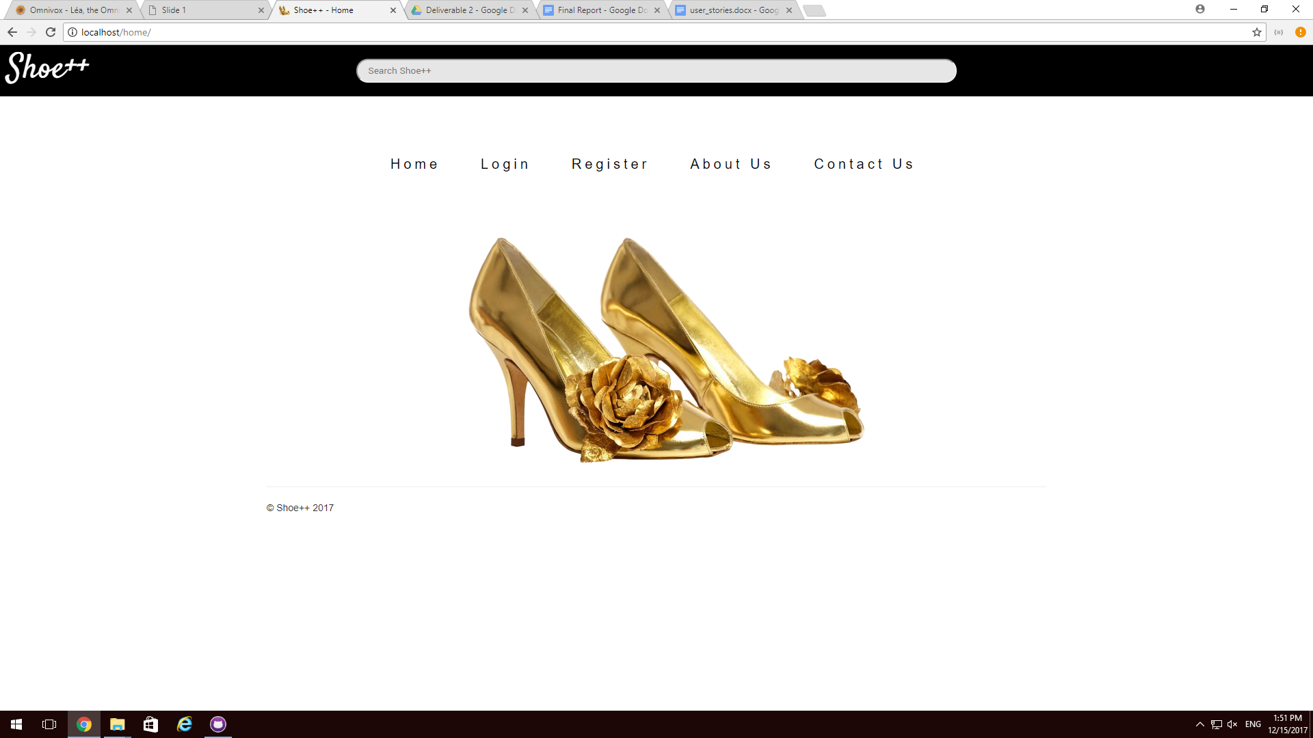

The logout can be confirmed because the navigation bar no longer shows “My Account” and “Logout”.

# 

# 

# 

# **Card 4:**

A user should be able to access the registration page from the login page (besides the navbar).

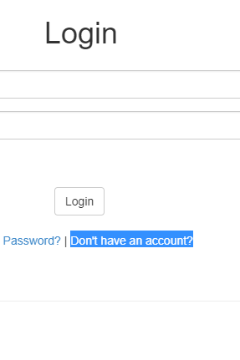**-->**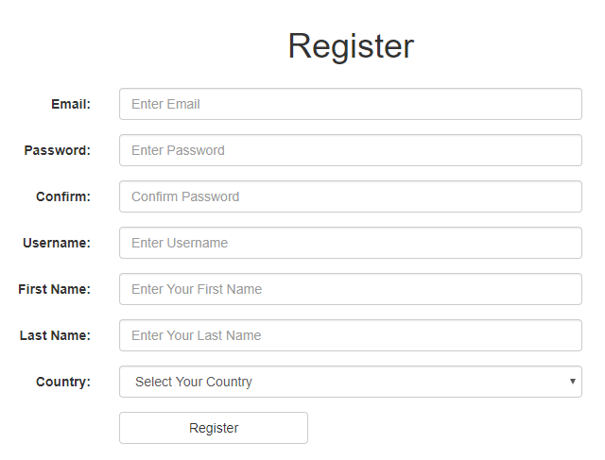

Once the ‘Don’t have an account?’ link is clicked upon, the user will be redirected to the ‘Register’ page in order to create a new account.

# **Card 5:**

An existing user should be able to change his password

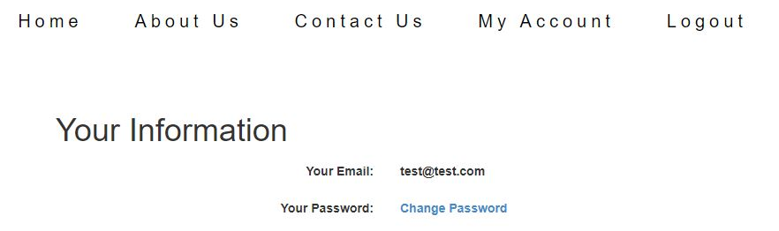

On the “My Account” page, there’s a hyperlink named “Change Password” where a user can go to.

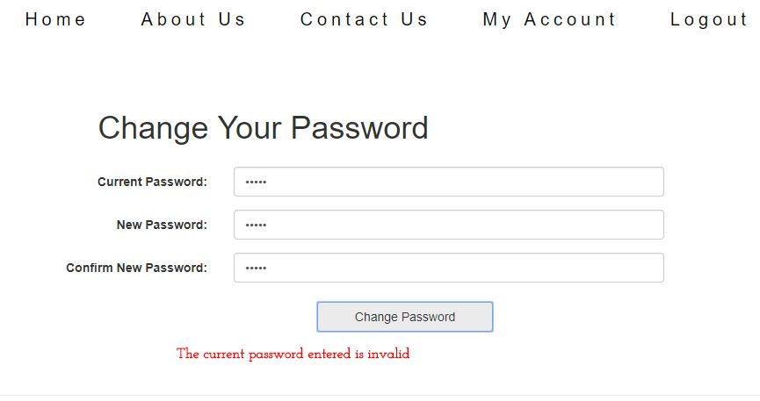

This is the change password form. The current password is required to change password. In this scenario, the user did not enter the correct password. The text “The current password entered is invalid” is shown.

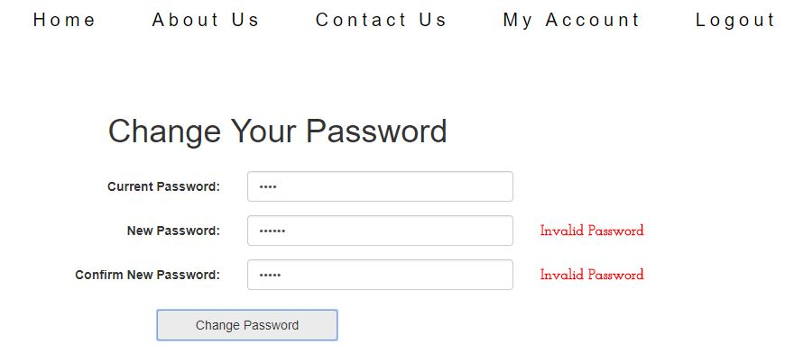

The “New Password” field and the “Confirm New Password” field should match. Otherwise an error message is shown.

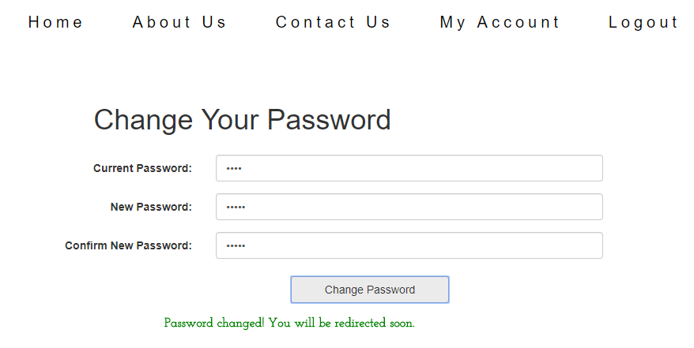

In this case all inputs are valid and the password has been changed. The message “Password changed! You will be redirected soon.” is shown.

# 

# 

# **Card 6:**

A user, as a buyer, can add items to his shopping cart

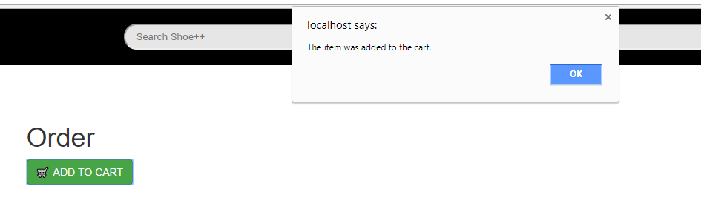

On an item’s page, there is a green button labeled “ADD TO CART”. Once clicked, pop up shows us confirming the item was added to the cart.

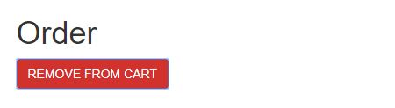

Also, the “ADD TO CART” button has changed to a red button labeled “REMOVE FROM CART”, confirming the item was added to the cart.

# 

# 

# **Card 7:**

If a user is not logged in and clicks the button to add an item to the cart, he will be redirected to the login page.

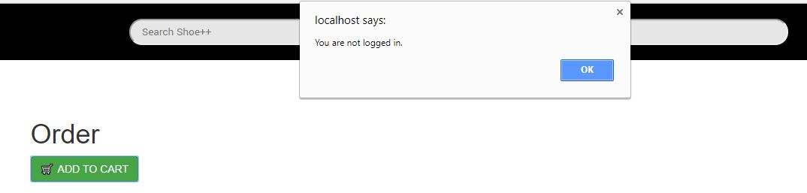

If the user is not logged in an attempts to add an item to the cart, an error message pops up saying “You are not logged in.”

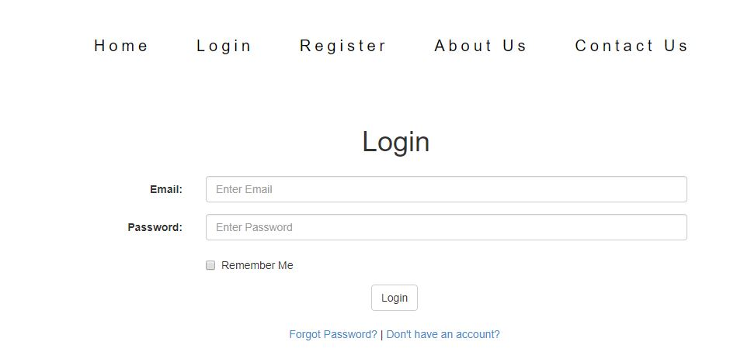

The user is then redirected to the login form.

# 

# 

# **Card 8:**

A user, as a buyer, can remove items from his shopping cart

If an item is still in the user’s cart, the user will have an option to remove the item from the cart on the item’s page.

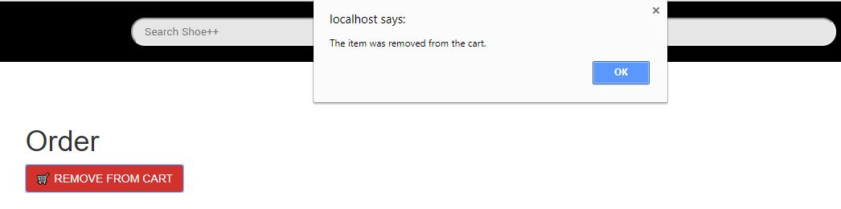

When clicked on the red “REMOVE FROM CART” button, a pop up shows up confirming the removal of the item.

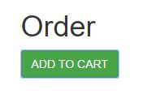

Finally, the red button has been changed to a green button labeled “ADD TO CART”. Once again, this confirm the removal of the item from the cart.

# 

# 

# **Card 9:**

A user, as a buyer, should be able to clear his shopping cart with a button

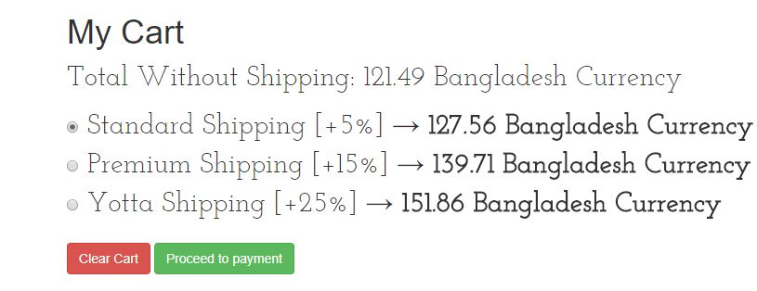

On the cart page, there is a red button labeled “Clear Cart”.



Once the button is clicked, the page is refreshed and a message confirming that there are no items in the cart is displayed.

# 

# 

# **Card 10:**

A user, as a buyer, should be able to proceed to the payment of all items in the shopping cart



On the cart page, there is a green button labeled “Proceed to payment”.

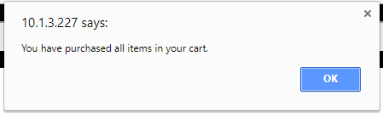

Once clicked, a pop up message shows up, confirming the purchase.

# **Card 11:**

The system should be able to calculate the total price of all items in the cart.

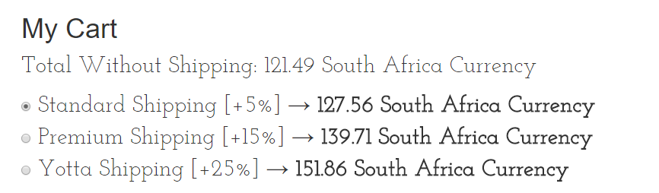

On the cart page, the system calculates the total price of all items without the shipping and then calculates the price with shipping accordingly.

# **Card 12:**

The system should display a message if there are no items in the cart.



If there are no items in the user’s cart, The message “You have no items in your cart” is displayed.

# **Card 13:**

A user should be able to view all items that were purchased under his account

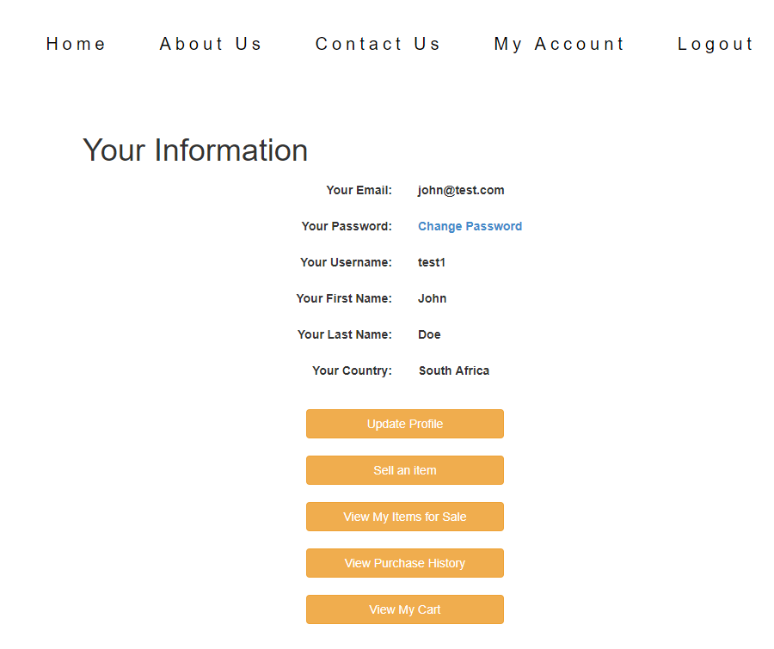

On the “My Account” page, there’s a button labeled “View Purchase History”.

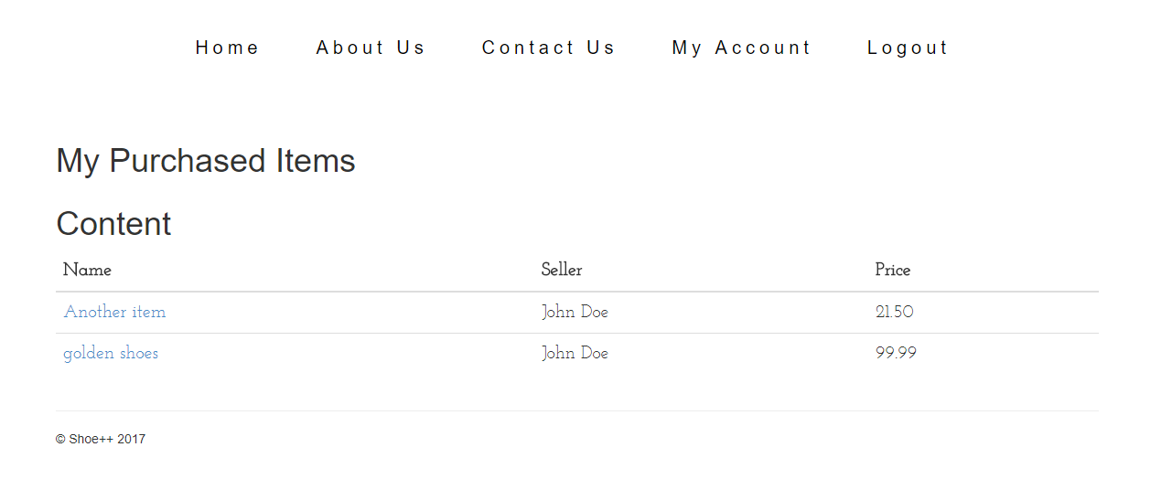

Once clicked, the user is directed to a page where all purchase items are listed.

# 

# 

# **Card 14:**

A user should be able to recommend an item to someone else by email

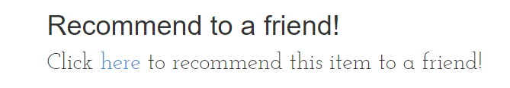

On every item’s page, there is a section where a user can recommend the item to a friend. When the hyperlink is clicked, the OS of the user prompts the user to select the email app to send the email with.

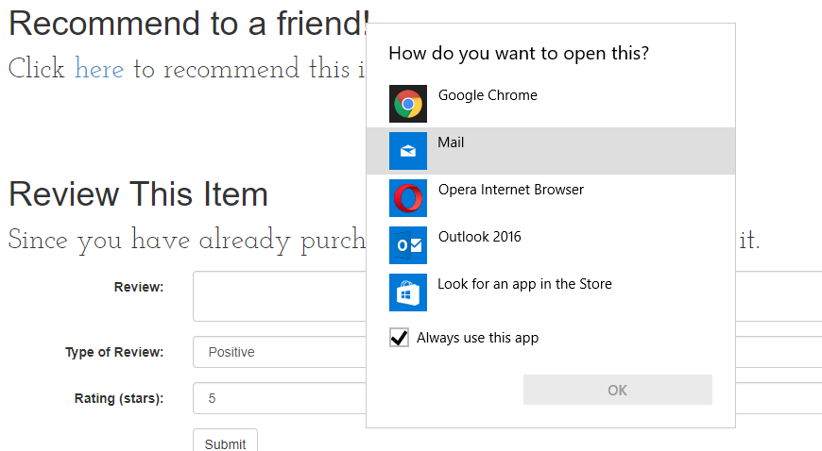

# 

# 

# **Card 15:**

A user, as a buyer, can review the item purchased.

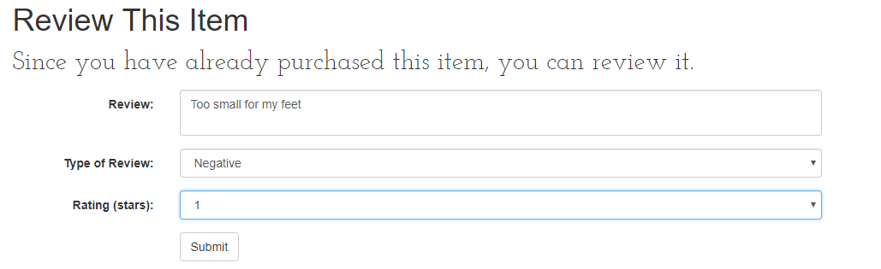

On every item’s page where the user has purchased the item, a section appears with a form allowing the user to write a review.

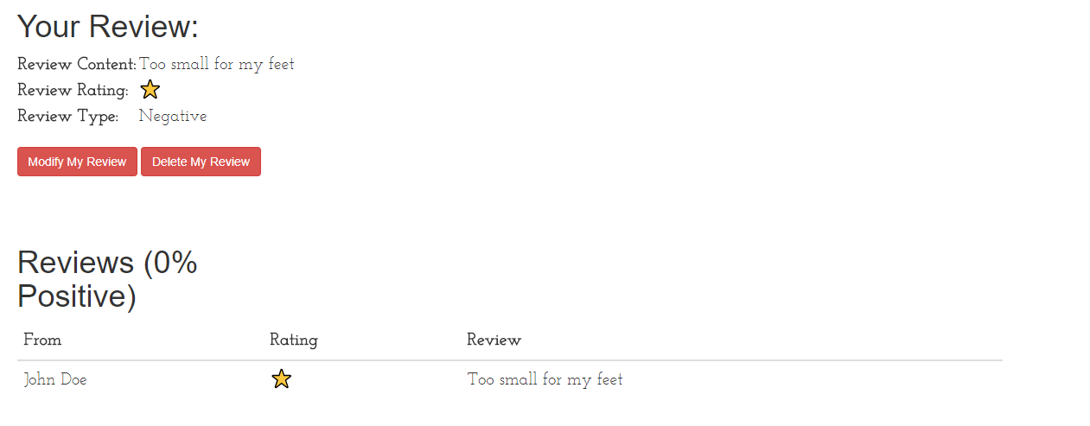

Once the submit button is clicked from the form, the page refreshes and the user can see his review posted.

# **Card 16:**

A user should be able to view all reviews for an item

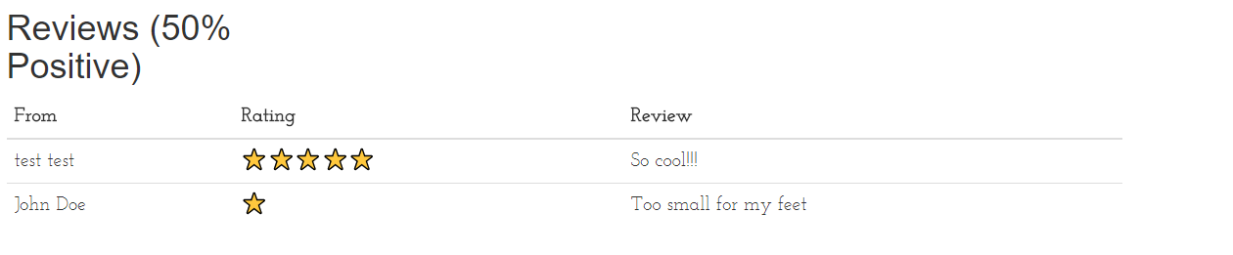

At the bottom of every item’s page, there is a sections for reviews where a user can see all reviews for an item (if there are any). If there are no reviews for an item, the following message is shown:

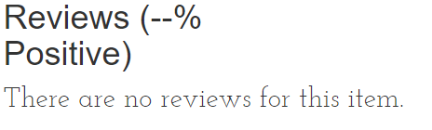

# **Card 17:**

A user should be able to delete his review

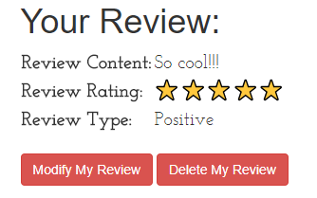**-->**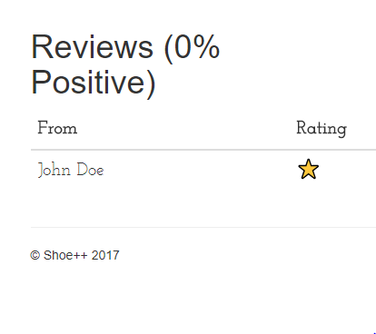

If the ‘Delete My Review’ button is clicked upon, the review that the logged in user posted will be deleted from the database and, subsequently, the ‘Reviews’ table.

# **Card 18:**

The system should be able to calculate and convert the price of one currency (ex. British Pound) to another (ex. Canadian Dollar).

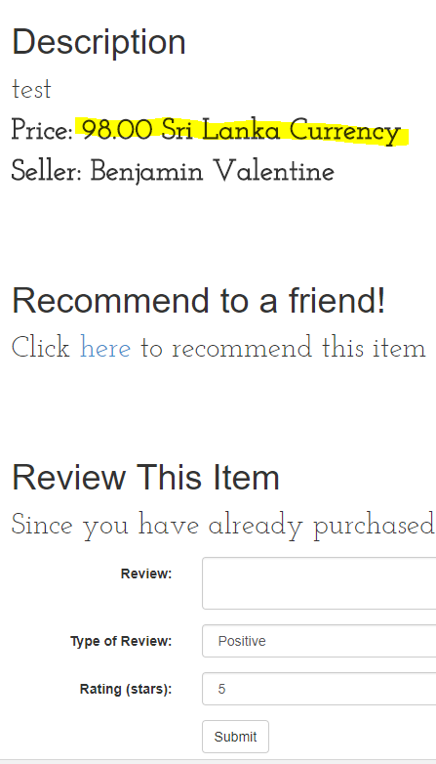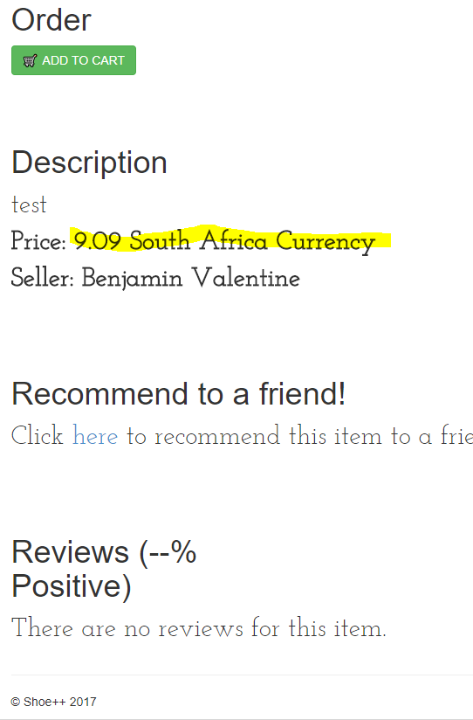

Two different users from two different countries may examine the same item, but at a different price. This is because it is adjusted to the local currency.

# **Card 19:**

The system should be able to display the positivity percentage next to an item’s ‘Reviews’ section.

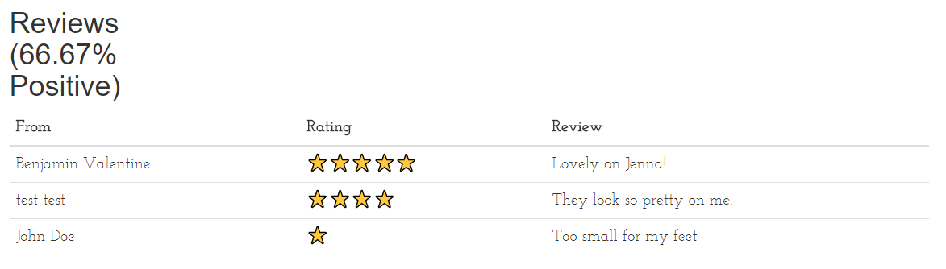

In the above example, the first two users listed their reviews as ‘Positive’ and the last user posted his review as ‘Negative’. Therefore, the positivity percentage is 66.67%.

# **Card 20:**

A user should be able to change his username (not the email address, but the flashy nickname).

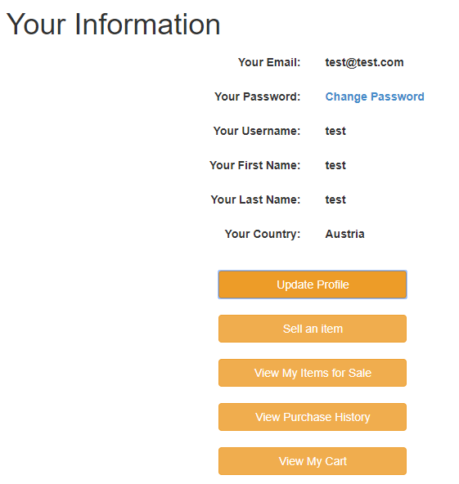**-->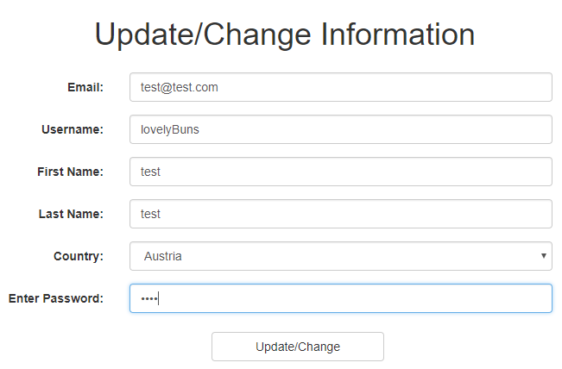-->**

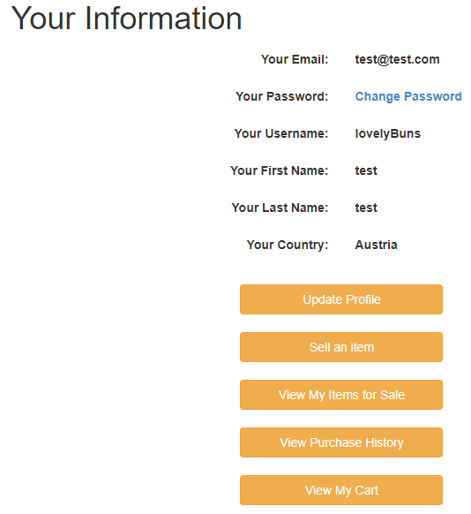

As shown above, the username can be changed in the ‘Update Profile’ section, so long as the password is provided.

# **Card 21:**

A user should be able to sell an item.

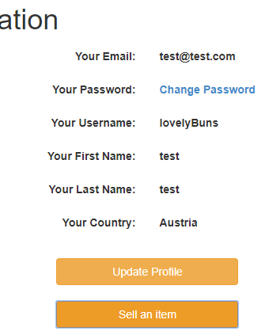**-->**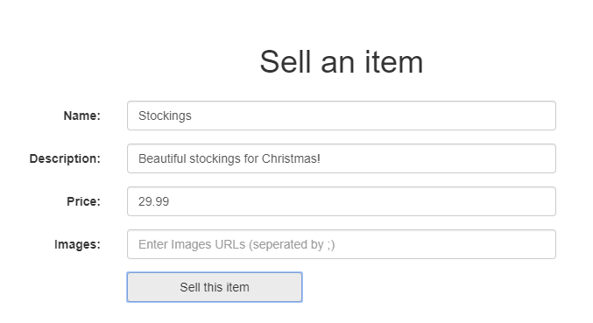

A user will be able to sell an item in the ‘Sell an item’ section. All fields are mandatory save for the images field.

# **Card 22:**

A user should be able to take down an item that they have put up for sale.

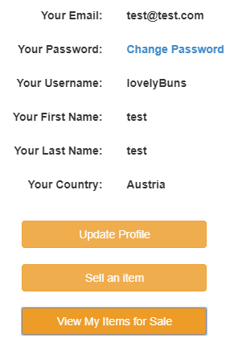**-->**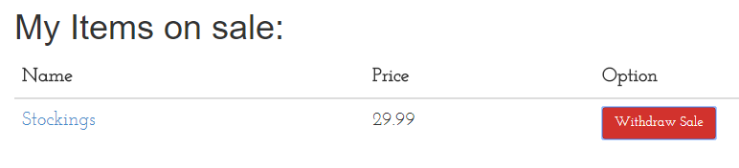

A user will be able to view their items for sale in the ‘View My Items for Sale’ section. From there, items can be taken down.

# **Card 23:**

A user should be able to view his cart as he is searching for items to purchase.

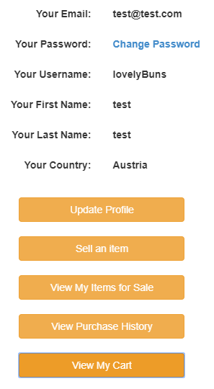**-->**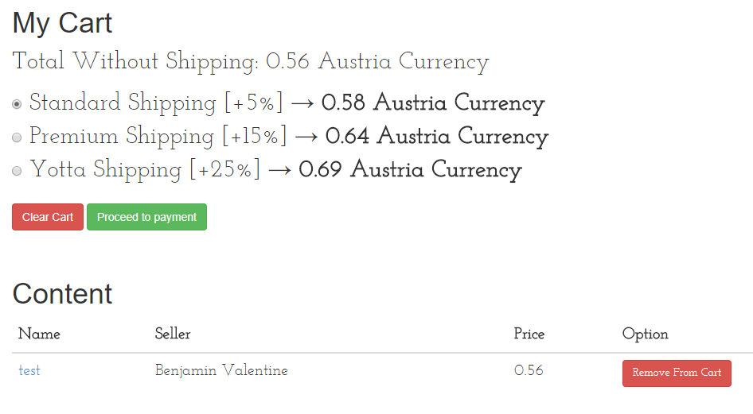

A user will be able to view their cart in the ‘View My Cart’ section. From there, items can be removed from the cart and all of the items can be purchased with one click of a button.

# **Card 24:**

A user should be able to view his user information.

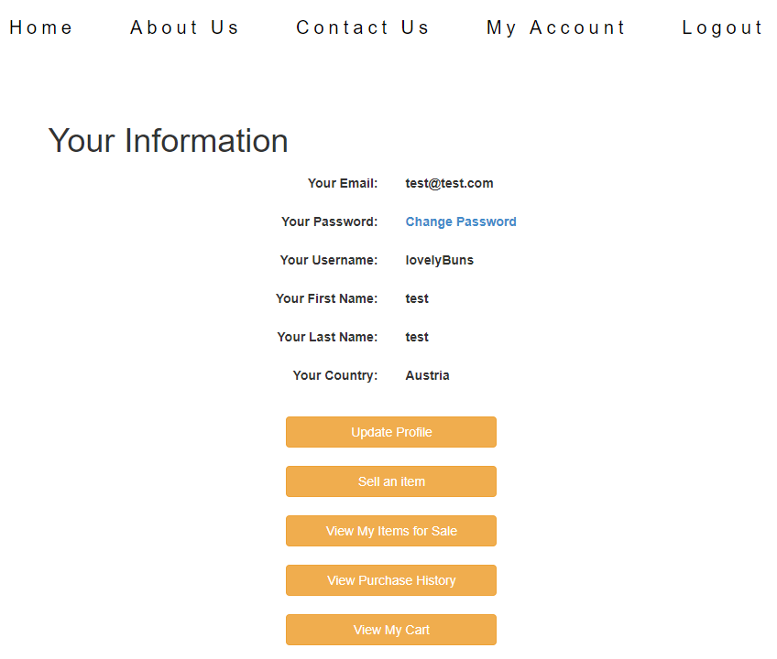

A user can view his or her information simply by clicking on the ‘My Account’ link in the navbar. Along with the information is a variety of links and buttons with different functions.

# **Card 25:**

A user should be able to change their country or change their email address (in terms of notifications, receipts, etc.). **-->**

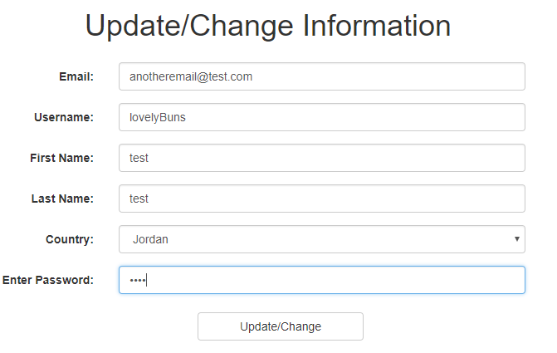**-->**

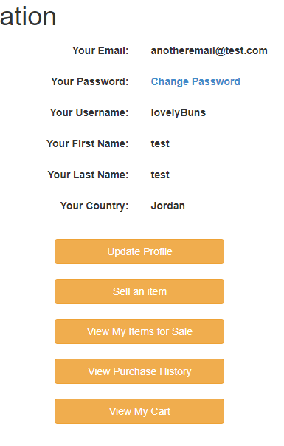

As shown above, the email and the country can be changed in the ‘Update Profile’ section, so long as the password is provided.

# **Card 26:**

A user should be able to search for an item by its name.

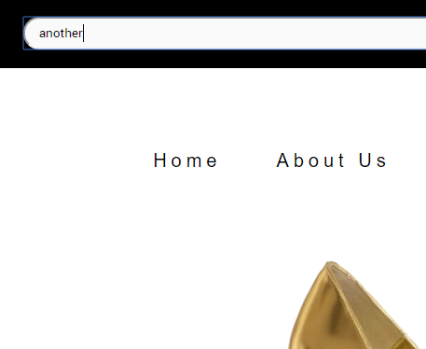**-->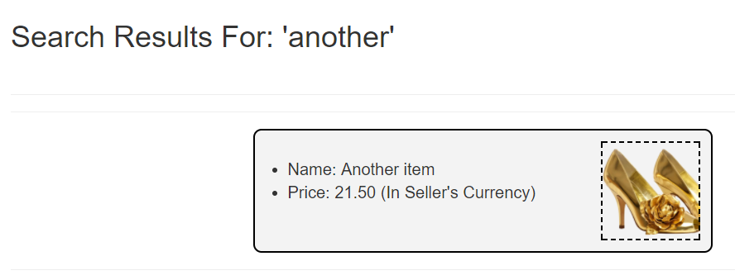-->**

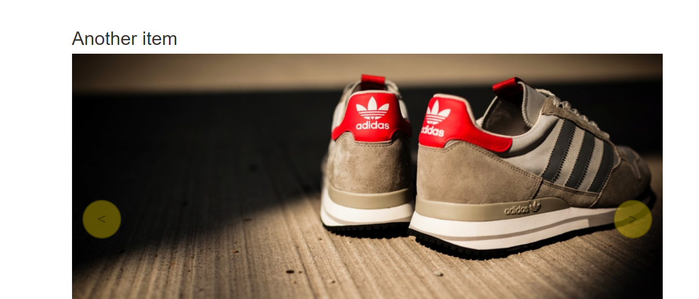

A user can search for an item by typing into the search bar a substring of the item’s name. In order to further examine a specific item, that specific link needs to be clicked upon in the ‘Search Results For:’ section.

# **Card 27:**

The user should be able to modify their review(s).

**-->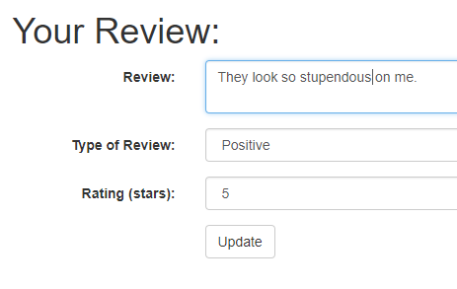-->**

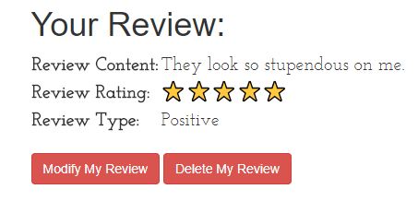

If the ‘Modify My Review’ button is clicked upon, a form with placeholders will display in which the user may update their review. Once done, they may click on the ‘update’ button to finalize these changes and update the database.

# **Card 28:**

A user should be able to navigate to a “About Us” Page where he can discover more about the Shoe++ business.

**-->**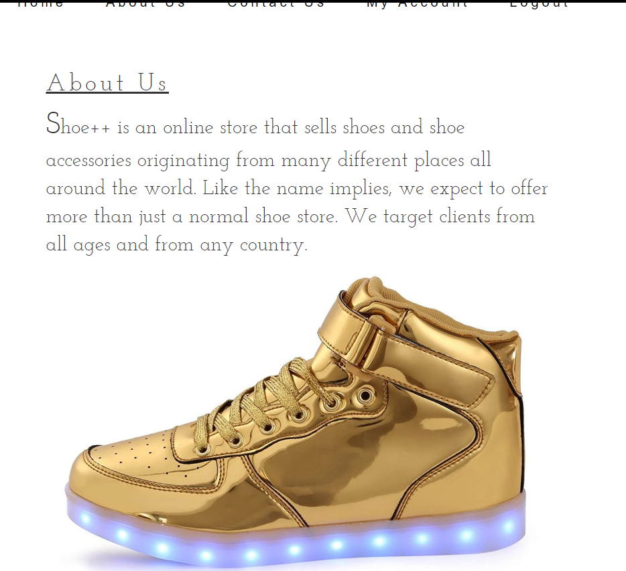

After clicking upon the ‘About Us’ link in the navbar, the user will be redirected to another page where they may learn more about Shoe++.

# **Card 29:**

A user should be able to change their first name or change their last name.

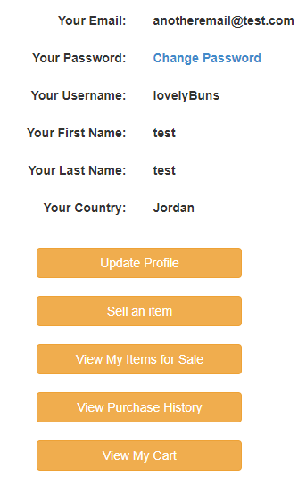**-->**

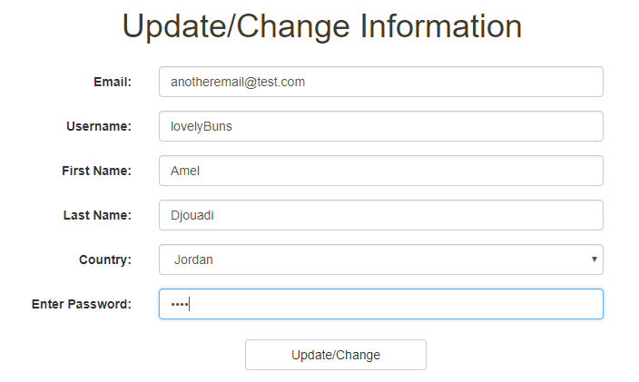**-->**

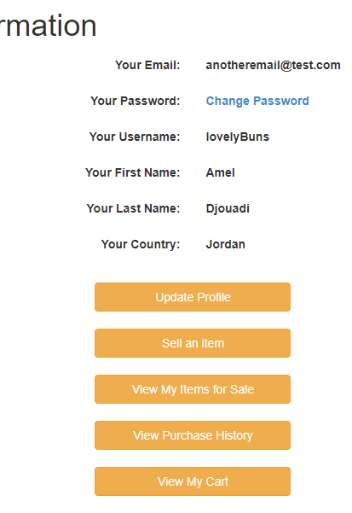

As shown above, the first name and the last name can be changed in the ‘Update Profile’ section, so long as the password is provided.

# **Card 30:**

A user should be able to select what shipping plan they would like to have as they are about to purchase an item (Standard Shipping [+5%], Premium Shipping [+15%], and Yotta Shipping [+25%] are the options).

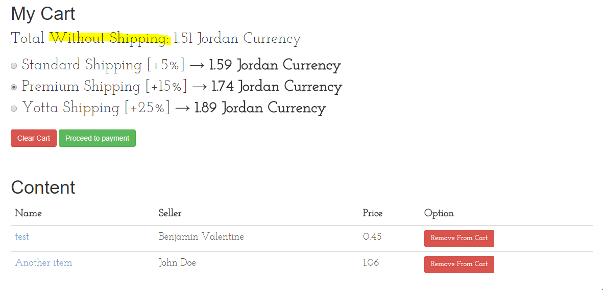

After the total price of the items is calculated (without shipping), another calculation is done for each of the three shipping radio buttons: withShipping = withoutShipping + (withoutShipping * 0.??). The check is set to ‘Standard Shipping’ by default, but the user may obviously change this. The more expensive the shipping, the sooner the item(s) is(are) expected to arrive. To finalize the grand total, the user needs to click on the ‘Proceed to payment’ button.